DNA methylation in breast cancer
towards precision medicine
Introduction
Breast cancer (BC) is a kind of solid tumour and the most common cancer in females, leading to 30% of female cancer cases and a significant health burden worldwide (Fan et al., 2014; Siegel et al., 2020). While genetic predisposition contributes to only about 10% of the cases (Lalloo & Evans, 2012), epigenetic factors, which alter gene function without changing DNA sequences, play a significant role (Pasculli et al., 2018). The reversibility of the factors may enable precision medicine, which can tailor therapies according to specific molecular bases in BC (Coleman, 2013).
DNA methylation is a major type of epigenetic change associated with oncogenesis (Easwaran & Baylin, 2019). The Cancer Genome Atlas (TCGA) has incorporated DNA methylation into its criteria for BC subtyping. In one subtype, there are reportedly 490 genes with hypermethylation, where the functional annotations vital to tumourigenesis, such as those of the “Wnt signalling pathway,” are altered (Koboldt et al., 2012). As the epigenetic diversity of BC implies different pathogenesis with different impacts on the treatment, precision medicine, which tailors therapies according to specific features of the patient (Pinker et al., 2018), should be used (Stefansson & Esteller, 2013; Pasculli et al., 2018).
There are three pillars for precision medicine based on DNA methylation, including 1) detection of DNA methylation and sequent analysis of pathogenesis, which enables patient stratification; 2) DNA methylation manipulation, which allows personalised therapies targeting DNA methylation; and 3) effective drug delivery platforms that ensure the therapies to work in the right place at the right time with the correct dosage. In this article, we will discuss these pillars in the context of BC.

Current State of Knowledge
Pillar 1: DNA methylation detection
Detection of molecular changes is the basis of precision medicine (Jones et al., 2019), which may explain BC heterogeneity and enable drug choice optimisation. For example, BRCA1 promoter hypermethylation is related to breast tumorigenesis (Dobrovic & Simpfendorfer, 1997; Rice et al., 2000). Since the TGFβ/miR-182/BRCA1 axis regulates cell differentiation (Martinez-Ruiz et al., 2016), loss of BRCA1 function due to DNA methylation may cause poorly differentiated, basal-like tumour tissues with a weaker response to chemo-drug cisplatin (Silver et al., 2010). Therefore, detecting BRCA1 promoter hypermethylation may help us avoid using drugs with poor efficacy.
To detect DNA methylation, one must know the molecular basis of DNA methylation. Chemically speaking, DNA methylation, which adds a methyl group to DNA, can happen in adenine and cytosine. In contrast, in mammals, it rarely occurs in adenine and usually coverts cytosine into 5-methyl cytosine (5mC) in CpG islands, where there are high cytosine-guanine dinucleotide repeats (Kumar et al., 2018). Early studies used methylation-sensitive restriction enzymes and affinity-based methods like chromatography to discover oncogenic DNA methylation (Compere & Palmiter, 1981; Herman et al., 1994), whereas bisulfite conversion, which only changes unmethylated cytosine to uracil, has enabled fast and high throughput measurement of DNA methylation (Bhattacharjee et al., 2018).
Computational models assist in further exploration of how DNA methylation is associated with BC heterogeneity (Przybilla et al., 2014). For example, Tong et al. (2018) developed an algorithm using the TCGA dataset to investigate the causal effects on tumorigenesis of promoter methylation. Kim et al. (2018) proposed a pathway-based model to predict cancer survival with DNA methylation profiles. Apart from the 5 clusters of BC subtypes with different DNA methylation patterns defined by TCGA (Koboldt et al., 2012), there are also other proposed epigenetic-based subtypes (Table 1).
Pillar 2: DNA methylation manipulation
DNA methylation manipulation enables therapies targeting the aberrant methylation in BC. Knowledge of DNA methylation machinery is essential for DNA methylation manipulation. DNA methylation is sustained by DNA-Methyl Transferases (DNMT) (Deaton & Bird, 2011; Jones, 2012), whereas the demethylation pathways are regulated by TET enzymes (Reddington et al., 2014) (Figure 1). After DNMT3a and DNMT3b introduce methylation to specific sequences, especially CpG islands (Ravichandran et al., 2018), DNMT1 tends to methylate new CpG islands whose partners on the parental strand are already methylated, leading to the inheritance of DNA methylation during DNA replication (Bird, 2002). DNA methylation hinders PRC binding to chromatin and triggers H3K27me3 redistribution, both of which mediate gene suppression (Koboldt et al., 2012; Reddington et al., 2014).
These enzymes in methylation and demethylation processes are ideal targets for DNA methylation manipulation. To reverse DNA methylation, the first approach is the manipulation of DNMT (Miranda Furtado et al., 2019), which is usually dysregulated in BC (Zhang & Xu, 2017). For example, Tang et al. (2014) used ectopic expression of miR-185 to reverse DNMT1 downregulation related to BRCA1 promoter hypermethylation. Another approach is the genetic engineering of methylation-associated enzymes (Pulecio et al., 2017). For example, Choudhury et al. (2016) fused the TET1 catalytic domain to the CRISPR-dCas9 system, which demethylated the BRCA1 promoter with the modified TET. dCas9-DNMT3a fusions are also used to manipulate DNA demethylation (Luo et al., 2018), although there is still no reported application in BC yet.
DNA methylation is developmentally regulated (Bergman & Cedar, 2013), which provides insights into cancer progression (Bergman & Cedar, 2013). Methyl-cytosine tends to be demethylated in non- CpG island regions, which causes global demethylation soon after early development, whereas DNA methylation accumulates due to ageing and environmental factors (Choudhury et al., 2016). In the epigenetic progenitor model (Figure 2), such alterations silence tumour-suppressor genes and substitute for mutation-induced oncogene activation. The cells with the alterations undergo neutral evolution and selection due to genetic and epigenetic instability, eventually resulting in cancer heterogeneity to allow cancer progression (Feinberg et al., 2006; Easwaran & Baylin, 2019).
Therefore, BC often develops epigenetic alterations to adapt to the selection of antitumour drugs (Figure 2), which makes reversing these alterations a way to treat patients with these alterations. Demethylation agents are therefore used to re-sensitise traditional therapies for BC, such as chemo- and radiotherapy (Lu et al., 2020). However, the combination of DNA demethylation agents, such as hydralazine and other antitumour drugs, has been examined by clinical trials, revealing mixed results in treating BC (Arce et al., 2006; Connolly et al., 2017), despite promising preclinical data (Lustberg & Ramaswamy, 2011). One possible reason is the low efficiency of drug delivery, reducing drug dosage in tumour tissue (Liu, 2012), which we will discuss in the next section.

Pillar 3: Precision delivery of epi-drugs
DNA methylation manipulation needs to work in the right place at the right time with enough dosage, which makes entry into the tumour microenvironment (TME) foremost for both DNA demethylation agents to effectively target BC (el Bahhaj et al., 2014). Besides, hypomethylation induced by methylation-inhibiting drugs like nucleoside-like compounds is harmful to healthy tissues and should be limited (Heerboth et al., 2014; Lu et al., 2020). Though low-dose use of DNA demethylation agents, e.g., decitabine, can effectively treat blood cancers, their efficacy in BC is still limited by low drug delivery efficiency and low sequent dosage due to the complexity of TME (Figure 3).
Capillary overgrowth increases the retention of nanoparticles in TME (Nichols & Bae, 2014; Danhier, 2016), which allows the passive delivery of epi-drugs (el Bahhaj et al., 2014). For example, Su et al. (2013) co-delivered a DNMT inhibitor and a chemo-drug with lipid-polymer nanoparticles to treat BC. However, the uneven distribution of blood vessels and reduced intercellular fluid exchange may hinder passive delivery (Nichols & Bae, 2014; Danhier, 2016). Active delivery, which can recognise specific stimuli in TME, such as DNA aptamer targeting DNMT inhibitor (Wang et al., 2019), may further help the drugs be released in tumour tissues for a prolonged period with a controlled dosage.

Future directions Improving the current therapeutic approach
Jameson & Longo (2015) have expressed concern over the low accuracy of commercially available biomarkers, which suggests the need for affordable and reliable detection techniques. Although there are clinical trials on the use of DNA methylation manipulation to sensitise traditional therapies for BC, only a small portion of patients prove to benefit from these epi-drugs (Ning et al., 2015; Connolly et al., 2017), indicating the urgent need of identification of the patients whom should benefit from the therapies through detection of specific DNA methylation. However, the biomarkers of BC are still not sensitive or specific enough (Guan et al., 2019), whereas methylation sequencing is relatively expensive (Laird, 2010), which may limit the use of the therapies.
Additionally, DNA methylation and demethylation processes interact with a broader range of regulators, such as lncRNA (Di Ruscio et al., 2013; Zhao et al., 2016), which needs further exploration. More importantly, we should integrate DNA methylation into the biological pathways that contribute to the heterogeneity of BC. For current epigenetic-based BC, subtypes are inconsistent in different studies (Table 1), so more data should be collected to build a unified model of the pathway-based networks and increase the robustness of epigenetic subtyping (Rivenbark et al., 2013).
Currently, DNA methylation manipulation does not always work as expected. Ford et al. (2017) and Korthauer & Irizarry (2018) reported only moderate transcriptional alterations after deposition of 5mC at thousands of gene promoters, which questions the effectiveness of DNA methylation manipulation and requires further research into methylation machinery (Luo et al., 2018) Besides, the efficacy of epi-drugs is also impacted by drug delivery efficiency, (Tsai & Baylin, 2011; Liu, 2012). Further research should also try to improve delivery efficiency with active delivery and other possible effective delivery systems (Venditto & Szoka Jr, 2013).
Epigenetic insights into cancer prevention
BC is primarily driven by DNA replication errors and environmental factors (Tomasetti et al., 2017), both of which are associated with DNA methylation. What causes DNA methylation remains poorly understood. DNA methylation may be part of the replication errors that accumulate during ageing. At the same time, environmental factors, such as pollutants and bioactive foods, may also contribute to DNA methylation (Romagnolo et al., 2016). Although replication errors are inevitable, the epigenetic progenitor model suggests that early intervention to stop the accumulation of these errors could help cancer prevention. Reversing DNA methylation could be a way to reduce errors. Considering the importance and difficulty of cancer prevention, it is worthy of further research to find the timing and methods of reversing DNA methylation to prevent cancer.
Conclusion
Epigenetic changes, especially DNA methylation, translate personal health conditions, including therapies, genetic abnormalities, intrinsic stimuli (e.g., ageing), and environmental stimuli (e.g., pollutants) into the uniqueness of breast cancer, which requires precision medicine to target these personalised conditions (Figure 4). DNA methylation detection enables new insights into methylation dynamics in tumourigenesis and typical development. Based on the insights, a set of epi-drugs and other tools targeting DNA methylation have been developed. However, further research is needed to improve the efficiency of DNA methylation manipulation through more effective drug delivery platforms and deepened insights into methylation machinery and its application. Ultimately, I believe these insights may allow early intervention and thus enable precision cancer prevention.

Tables & Figures
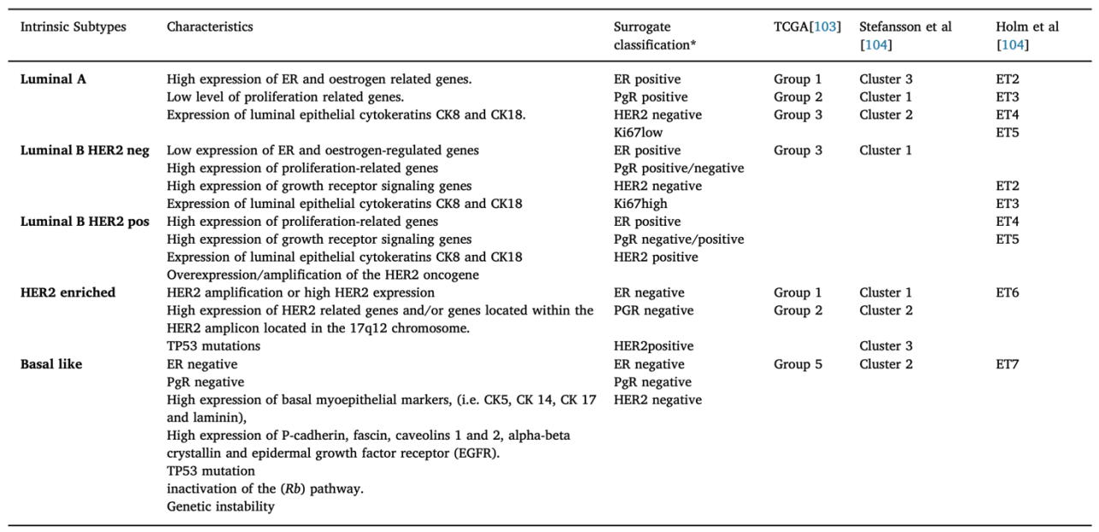
Table 1. Epigenetic-based subtypes of BC summarised by Pasculli et al. (2018).
For epigenetic-based subtyping, TCGA uses a comprehensive approach for subtyping BC, including DNA methylation data, while both Stefansson et al. (2015) and Holm et al. (2010) subtypes BC based on DNA methylation. Intrinsic subtypes are genetic-based (Perou et al., 2000), which have been widely recognised as the subtypes of BC and associated with many unique characteristics, as the Table shows. Surrogate classification is based on a combination of the routine pathological markers ER, PR, and HER2 and the proliferation marker Ki67 (Lundgren et al., 2019). 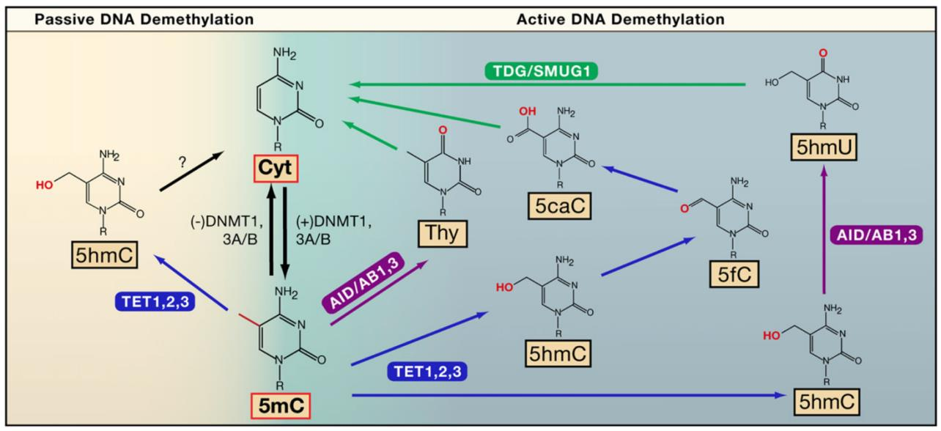
Figure 1. DNA demethylation pathways, according to Chekhun et al. (2007).
DNMT3A/B introduces de novo DNA methylation to specific gene sequences during development. The methylation is sustained by DNMT1, which can methylate unmethylated DNA strands during DNA replication. Due to the mutagenic property of cytosine, demethylation will happen spontaneously without the protection of CpG islands and DNMT1, which is the passive methylation pathway. Meanwhile, DNA repair actively demethylates DNA through different pathways, where TET enzymes and other enzymes are involved (Bhutani et al., 2011). Both active and passive demethylation contributes to the dynamics of DNA methylation, which can be a target for BC therapy, given the popularity of DNA methylation in BC.
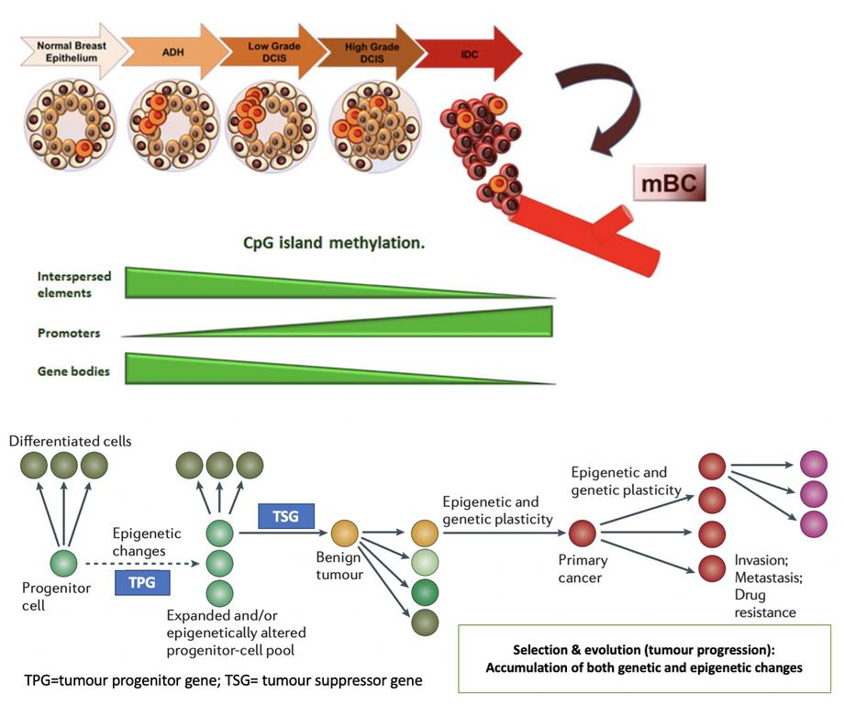
Figure 2. DNA methylation during BC progression and mechanistic explanation based on the epigenetic progenitor model. Adapted from Pasculli et al. (2018) and Feinberg et al. (2006).
Invasive ductal carcinoma (IDC) is the most common breast cancer type. Following cancer cells arising in normal breast epithelium, no-obliged pre-invasive lesions, termed Atypical Ductal Hyperplasia (ADH) and/or Ductal Carcinoma in situ (DCIS), are formed. The grade of the carcinoma progressively increases to finally result in metastasis. The process is accompanied by DNA methylation reprogramming, characterised by increased promoter region methylation and demethylation of gene bodies and repetitive sequences (Pasculli et al., 2018). According to the epigenetic progenitor model, these methylation alterations could accumulate before oncogenesis (Feinberg et al., 2006). Cancer can be regarded as a disease of cell division caused by dysregulated gene expression in a tumour-progenitor cell due to epigenetic changes. The alterations lead to tumourigenesis when there is a lack of tumour suppressor gene expression due to either genetic mutation or epigenetic silencing. The cells with the alteration will undergo selection due to instability caused by the alteration, which enhances the alteration with genetic and epigenetic plasticity, resulting in sequential changes in DNA methylation in favour of tumourigenesis and against antitumour drugs even if there are no genetic changes.

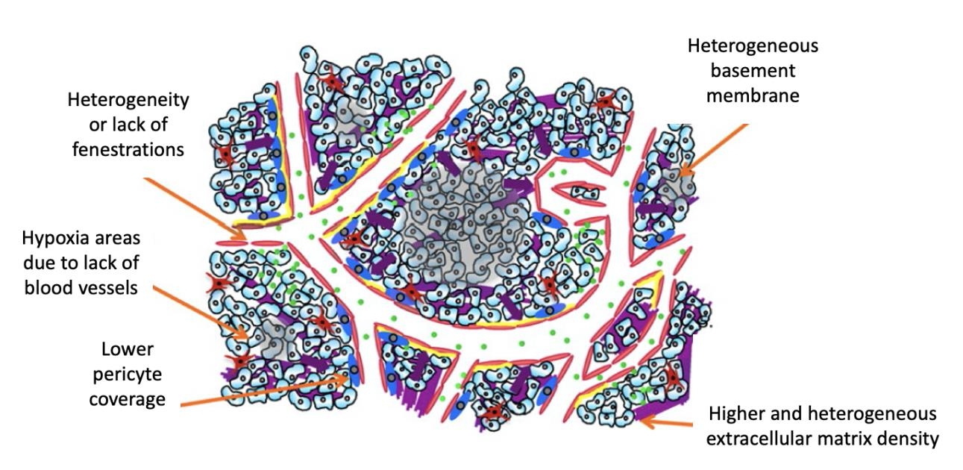
Figure 3. Characteristics of TME that stop drug uptake. Adapted from Danhier (2016).
These alterations contribute to a higher interstitial fluid pressure that reduces material exchange between blood and intercellular matrix, which disadvantages drug uptake and lowers drug efficacy. Blood vessel overgrowth in cancer often leads to increased retention of nano drugs in the tumour, but the effect is not significant in the solid human tumour due to these characteristics of TME. Therefore, active delivery of epi-drugs targeting tumour tissues, prolonged retention in tumour tissues, and continuous release of these drugs are essential for treating solid tumours like BC.

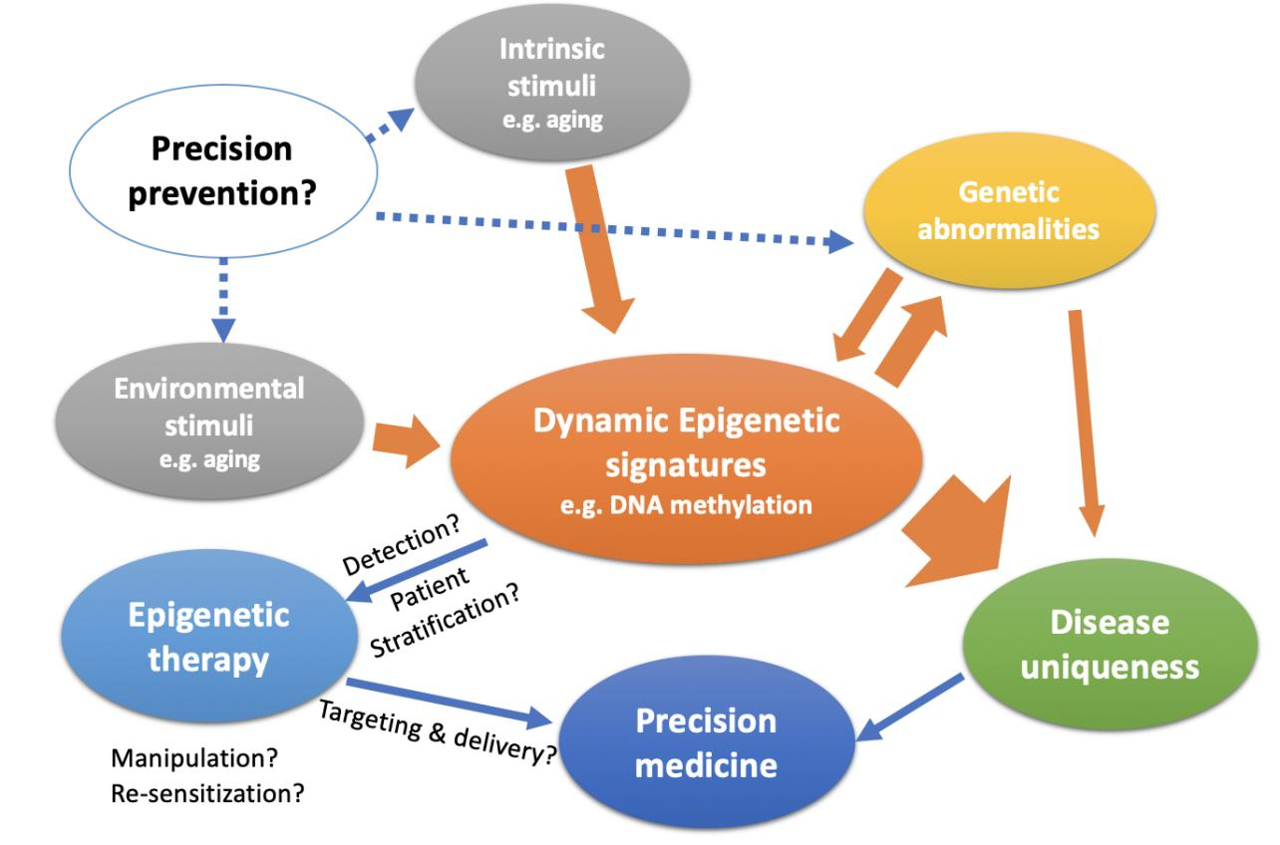
Figure 4. Graphic summary of how epigenetic therapy is related to precision medicine. Partly adapted from Liu (2012).
Dynamic epigenetic signatures translate both environmental and intrinsic stimuli and genetic abnormalities into disease uniqueness, requiring precision medicine. By detecting DNA methylation, we can stratify the patients according to their epigenetic traits and tailor the epigenetic therapies accordingly. As part of epigenetic therapy, epi-drugs are designed to reverse DNA methylation and/or re-sensitise traditional treatments such as chemo- and radiotherapy, which may need nanoparticle-based active drug delivery systems to increase efficacy by penetrating TME. With the development of techniques to detect and manipulate DNA methylation and an increased understanding of DNA methylation dynamics in tumourigenesis, early intervention according to DNA methylation profiles could enable BC prevention.

References
ARCE, C., PÉREZ-PLASENCIA, C., GONZÁLEZ-FIERRO, A., DE LA CRUZ-HERNÁNDEZ, E., REVILLA- VÁZQUEZ, A., CHÁVEZ-BLANCO, A., TREJO-BECERRIL, C., PÉREZ-CÁRDENAS, E., TAJA-CHAYEB, L., BARGALLO, E., VILLARREAL, P., RAMÍREZ, T., VELA, T., CANDELARIA, M., CAMARGO, M. F., ROBLES, E. & DUEÑAS-GONZÁLEZ, A. (2006) A Proof-Of-Principle Study of Epigenetic Therapy Added to Neoadjuvant Doxorubicin Cyclophosphamide for Locally Advanced Breast Cancer, PLOS ONE. 1(1): e98.
EL BAHHAJ, F., DEKKER, F. J., MARTINET, N. & BERTRAND, P. (2014) Delivery of epidrugs, Drug Discovery Today. 19(9): 1337–1352.
BERGMAN, Y. & CEDAR, H. (2013) DNA methylation dynamics in health and disease, Nature Structural & Molecular Biology. 20(3): 274–281.
BHATTACHARJEE, R., MORIAM, S., UMER, M., NGUYEN, N. T. & SHIDDIKY, M. J. A. (2018) DNA methylation detection: Recent developments in bisulfite free electrochemical and optical approaches, Analyst. 4802–4818.
BHUTANI, N., BURNS, D. M. & BLAU, H. M. (2011) DNA demethylation dynamics, Cell. 146(6): 866– 872.
BIRD, A. (2002) DNA methylation patterns and epigenetic memory, Genes & Development . 16(1): 6–21.
CHEKHUN, V. F., LUKYANOVA, N. Y., KOVALCHUK, O., TRYNDYAK, V. P. & POGRIBNY, I. P. (2007) Epigenetic profiling of multidrug-resistant human MCF-7 breast adenocarcinoma cells reveals novel hyper- and hypomethylated targets, Molecular Cancer Therapeutics. 6(3): 1089 LP – 1098.
CHOUDHURY, S. R., CUI, Y., LUBECKA, K., STEFANSKA, B. & IRUDAYARAJ, J. (2016) CRISPR-dCas9 mediated TET1 targeting for selective DNA demethylation at BRCA1 promoter, Oncotarget. 7(29): 46545–46556.
COLEMAN, W. B. (2013) Breast Cancer Personalized Medicine: Challenges and Opportunities, The American Journal of Pathology. 183(4): 1036–1037.
COMPERE, S. J. & PALMITER, R. D. (1981) DNA methylation controls the inducibility of the mouse metallothionein-I gene in lymphoid cells, Cell. 25(1): 233–240.
CONNOLLY, R. M. ET AL. (2017) Combination Epigenetic Therapy in Advanced Breast Cancer with 5- Azacitidine and Entinostat: A Phase II National Cancer Institute/Stand Up to Cancer Study, Clinical cancer research : an official journal of the American Association for Cancer Research. 2016/12/15. 23(11): 2691–2701.
DANHIER, F. (2016) To exploit the tumor microenvironment: Since the EPR effect fails in the clinic, what is the future of nanomedicine?, Journal of Controlled Release. 244: 108–121.
DEATON, A. M. & BIRD, A. (2011) CpG islands and the regulation of transcription, Genes & development. 25(10): 1010–1022.
DOBROVIC, A. & SIMPFENDORFER, D. (1997) Methylation of the BRCA1 gene in sporadic breast cancer, Cancer research. 57(16): 3347–3350.
EASWARAN, H. & BAYLIN, S. B. (2019) Origin and Mechanisms of DNA Methylation Dynamics in Cancers BT - The DNA, RNA, and Histone Methylomes, in Jurga, S. and Barciszewski, J. (eds). 27–52.
FAN, L., STRASSER-WEIPPL, K., LI, J.-J., ST LOUIS, J., FINKELSTEIN, D. M., YU, K.-D., CHEN, W.-Q., 9
SHAO, Z.-M. & GOSS, P. E. (2014) Breast cancer in China, The Lancet Oncology. 15(7): e279– e289.
FEINBERG, A. P., OHLSSON, R. & HENIKOFF, S. (2006) The epigenetic progenitor origin of human cancer, Nature Reviews Genetics. 7(1): 21–33.
FORD, E., GRIMMER, M. R., STOLZENBURG, S., BOGDANOVIC, O., MENDOZA, A. DE, FARNHAM, P. J., BLANCAFORT, P. & LISTER, R. (2017) Frequent lack of repressive capacity of promoter DNA methylation identified through genome-wide epigenomic manipulation, bioRxiv. 170506.
GUAN, Z., YU, H., CUK, K., ZHANG, Y. & BRENNER, H. (2019) Whole-Blood DNA Methylation Markers in Early Detection of Breast Cancer: A Systematic Literature Review, Cancer Epidemiology Biomarkers & Prevention. 28(3): 496 LP – 505.
HEERBOTH, S., LAPINSKA, K., SNYDER, N., LEARY, M., ROLLINSON, S. & SARKAR, S. (2014) Use of epigenetic drugs in disease: an overview, Genetics & epigenetics. 6: 9–19.
HERMAN, J. G., LATIF, F., WENG, Y., LERMAN, M. I., ZBAR, B., LIU, S., SAMID, D., DUAN, D. S., GNARRA, J. R. & LINEHAN, W. M. (1994) Silencing of the VHL tumor-suppressor gene by DNA methylation in renal carcinoma, Proceedings of the National Academy of Sciences. 91(21): 9700 LP – 9704.
HOLM, K., HEGARDT, C., STAAF, J., VALLON-CHRISTERSSON, J., JÖNSSON, G., OLSSON, H., BORG, Å. & RINGNÉR, M. (2010) Molecular subtypes of breast cancer are associated with characteristic DNA methylation patterns, Breast Cancer Research. 12(3): R36.
JAMESON, J. L. & LONGO, D. L. (2015) Precision Medicine — Personalized, Problematic, and Promising, New England Journal of Medicine. 372(23): 2229–2234.
JONES, D. T. W., BANITO, A., GRÜNEWALD, T. G. P., HABER, M., JÄGER, N., KOOL, M., MILDE, T., MOLENAAR, J. J., NABBI, A., PUGH, T. J., SCHLEIERMACHER, G., SMITH, M. A., WESTERMANN, F. & PFISTER, S. M. (2019) Molecular characteristics and therapeutic vulnerabilities across paediatric solid tumours, Nature Reviews Cancer. 19(8): 420–438.
JONES, P. A. (2012) Functions of DNA methylation: islands, start sites, gene bodies and beyond, Nature Reviews Genetics. 13(7): 484–492.
KIM, S. Y., KIM, T. R., JEONG, H.-H. & SOHN, K.-A. (2018) Integrative pathway-based survival prediction utilising the interaction between gene expression and DNA methylation in breast cancer, BMC Medical Genomics. 11(3): 68.
KOBOLDT, D. C. ET AL. (2012) Comprehensive molecular portraits of human breast tumours, Nature. 490(7418): 61–70.
KORTHAUER, K. & IRIZARRY, R. A. (2018) Genome-wide repressive capacity of promoter DNA methylation is revealed through epigenomic manipulation, bioRxiv. 381145.
KUMAR, S., CHINNUSAMY, V. & MOHAPATRA, T. (2018) Epigenetics of Modified DNA Bases: 5- Methylcytosine and Beyond, Frontiers in Genetics. 9: 640.
LAIRD, P. W. (2010) Principles and challenges of genome-wide DNA methylation analysis, Nature Reviews Genetics. 11(3): 191–203.
LALLOO, F. & EVANS, D. G. (2012) Familial Breast Cancer, Clinical Genetics. 82(2): 105–114.
LIU, S. (2012) Epigenetics advancing personalised nanomedicine in cancer therapy, Advanced Drug
Delivery Reviews. 64(13): 1532–1543.
LU, Y., CHAN, Y.-T., TAN, H.-Y., LI, S., WANG, N. & FENG, Y. (2020) Epigenetic regulation in human
cancer: the potential role of epi-drug in cancer therapy, Molecular cancer. 19(1): 79. 10
LUNDGREN, C., BENDAHL, P.-O., BORG, Å., EHINGER, A., HEGARDT, C., LARSSON, C., LOMAN, N., MALMBERG, M., OLOFSSON, H., SAAL, L. H., SJÖBLOM, T., LINDMAN, H., KLINTMAN, M., HÄKKINEN, J., VALLON-CHRISTERSSON, J., FERNÖ, M., RYDÉN, L. & EKHOLM, M. (2019) Agreement between molecular subtyping and surrogate subtype classification: a contemporary population-based study of ER-positive/HER2-negative primary breast cancer, Breast Cancer Research and Treatment. 178(2): 459–467.
LUO, C., HAJKOVA, P. & ECKER, J. R. (2018) Dynamic DNA methylation: In the right place at the right time, Science. 361(6409): 1336 LP – 1340.
LUSTBERG, M. B. & RAMASWAMY, B. (2011) Epigenetic Therapy in Breast Cancer, Current breast cancer reports. 3(1): 34–43.
MARTINEZ-RUIZ, H., ILLA-BOCHACA, I., OMENE, C., HANNIFORD, D., LIU, Q., HERNANDO, E. & BARCELLOS-HOFF, M. H. (2016) A TGFβ–miR-182–BRCA1 axis controls the mammary differentiation hierarchy, Science Signaling. 9(457): ra118 LP-ra118.
MIRANDA FURTADO, C. L., DOS SANTOS LUCIANO, M. C., SILVA SANTOS, R. DA, FURTADO, G. P., MORAES, M. O. & PESSOA, C. (2019) Epidrugs: targeting epigenetic marks in cancer treatment, Epigenetics. 14(12): 1164–1176.
NICHOLS, J. W. & BAE, Y. H. (2014) EPR: Evidence and fallacy, Journal of Controlled Release. 190: 451–464.
NING, B., LI, W., ZHAO, W. & WANG, R. (2015) Targeting epigenetic regulations in cancer, Acta Biochimica et Biophysica Sinica. 48(1): 97–109.
PASCULLI, B., BARBANO, R. & PARRELLA, P. (2018) Epigenetics of breast cancer: Biology and clinical implication in the era of precision medicine, Seminars in Cancer Biology. 51: 22–35.
PEROU, C. M., SØRLIE, T., EISEN, M. B., VAN DE RIJN, M., JEFFREY, S. S., REES, C. A., POLLACK, J. R., ROSS, D. T., JOHNSEN, H., AKSLEN, L. A., FLUGE, Ø., PERGAMENSCHIKOV, A., WILLIAMS, C., ZHU, S. X., LØNNING, P. E., BØRRESEN-DALE, A.-L., BROWN, P. O. & BOTSTEIN, D. (2000) Molecular portraits of human breast tumours, Nature. 406(6797): 747–752.
PINKER, K., CHIN, J., MELSAETHER, A. N., MORRIS, E. A. & MOY, L. (2018) Precision Medicine and Radiogenomics in Breast Cancer: New Approaches toward Diagnosis and Treatment, Radiology. 287(3): 732–747.
PRZYBILLA, J., ROHLF, T., LOEFFLER, M. & GALLE, J. (2014) Understanding epigenetic changes in aging stem cells – a computational model approach, Aging Cell. 13(2): 320–328.
PULECIO, J., VERMA, N., MEJÍA-RAMÍREZ, E., HUANGFU, D. & RAYA, A. (2017) CRISPR/Cas9-Based Engineering of the Epigenome, Cell Stem Cell. 21(4): 431–447.
RAVICHANDRAN, M., JURKOWSKA, R. Z. & JURKOWSKI, T. P. (2018) Target specificity of mammalian DNA methylation and demethylation machinery, Organic & biomolecular chemistry. 16(9): 1419–1435.
REDDINGTON, J. P., SPROUL, D. & MEEHAN, R. R. (2014) DNA methylation reprogramming in cancer: does it act by re-configuring the binding landscape of Polycomb repressive complexes?, BioEssays : news and reviews in molecular, cellular and developmental biology. 2013/11/26. 36(2): 134–140.
RICE, J. C., OZCELIK, H., MAXEINER, P., ANDRULIS, I. & FUTSCHER, B. W. (2000) Methylation of the BRCA1 promoter is associated with decreased BRCA1 mRNA levels in clinical breast cancer specimens , Carcinogenesis. 21(9): 1761–1765.
RIVENBARK, A. G., O’CONNOR, S. M. & COLEMAN, W. B. (2013) Molecular and Cellular Heterogeneity 11
in Breast Cancer: Challenges for Personalized Medicine, The American Journal of Pathology. 183(4): 1113–1124.
ROMAGNOLO, D. F., DANIELS, K. D., GRUNWALD, J. T., RAMOS, S. A., PROPPER, C. R. & SELMIN, O. I. (2016) Epigenetics of breast cancer: Modifying role of environmental and bioactive food compounds, Molecular nutrition & food research. 60(6): 1310–1329.
DI RUSCIO, A., EBRALIDZE, A. K., BENOUKRAF, T., AMABILE, G., GOFF, L. A., TERRAGNI, J., FIGUEROA, M. E., PONTES, L. L. D. F., ALBERICH-JORDA, M. & ZHANG, P. (2013) DNMT1-interacting RNAs block gene-specific DNA methylation, Nature. 503(7476): 371–376.
SIEGEL, R. L., MILLER, K. D. & JEMAL, A. (2020) Cancer statistics, 2020, CA: A Cancer Journal for Clinicians. 70(1): 7–30.
SILVER, D. P., RICHARDSON, A. L., EKLUND, A. C., WANG, Z. C., SZALLASI, Z., LI, Q., JUUL, N., LEONG, C.-O., CALOGRIAS, D. & BURAIMOH, A. (2010) Efficacy of neoadjuvant Cisplatin in triple- negative breast cancer, Journal of clinical oncology. 28(7): 1145.
STEFANSSON, O. A. & ESTELLER, M. (2013) Epigenetic Modifications in Breast Cancer and Their Role in Personalized Medicine, The American Journal of Pathology. 183(4): 1052–1063.
STEFANSSON, O. A., MORAN, S., GOMEZ, A., SAYOLS, S., ARRIBAS-JORBA, C., SANDOVAL, J., HILMARSDOTTIR, H., OLAFSDOTTIR, E., TRYGGVADOTTIR, L. & JONASSON, J. G. (2015) A DNA methylation‐based definition of biologically distinct breast cancer subtypes, Molecular oncology. 9(3): 555–568.
SU, X., WANG, Z., LI, L., ZHENG, M., ZHENG, C., GONG, P., ZHAO, P., MA, Y., TAO, Q. & CAI, L. (2013) Lipid-polymer nanoparticles encapsulating doxorubicin and 2′-deoxy-5-azacytidine enhance the sensitivity of cancer cells to chemical therapeutics, Molecular Pharmaceutics. 10(5): 1901–1909.
TANG, H., LIU, P., YANG, L., XIE, XINHUA, YE, F., WU, M., LIU, X., CHEN, B., ZHANG, L. & XIE, XIAOMING (2014) miR-185 Suppresses Tumor Proliferation by Directly Targeting E2F6 and DNMT1 and Indirectly Upregulating BRCA1 in Triple-Negative Breast Cancer, Molecular Cancer Therapeutics. 13(12): 3185 LP – 3197.
TOMASETTI, C., LI, L. & VOGELSTEIN, B. (2017) Stem cell divisions, somatic mutations, cancer etiology, and cancer prevention, Science. 355(6331): 1330 LP – 1334.
TONG, Y., SUN, J., WONG, C. F., KANG, Q., RU, B., WONG, C. N., CHAN, A. S., LEUNG, S. Y. & ZHANG, J. (2018) MICMIC: identification of DNA methylation of distal regulatory regions with causal effects on tumorigenesis, Genome Biology. 19(1): 73.
TSAI, H.-C. & BAYLIN, S. B. (2011) Cancer epigenetics: linking basic biology to clinical medicine, Cell research. 2011/02/15. 21(3): 502–517.
VENDITTO, V. J. & SZOKA JR, F. C. (2013) Cancer nanomedicines: so many papers and so few drugs!, Advanced drug delivery reviews. 2012/10/01. 65(1): 80–88.
WANG, L., LEE, J. Y., GAO, L., YIN, J., DUAN, Y., JIMENEZ, L. A., ADKINS, G. B., REN, W., LI, L., FANG, J., WANG, Y., SONG, J. & ZHONG, W. (2019) A DNA aptamer for binding and inhibition of DNA methyltransferase 1, Nucleic Acids Research. 47(22): 11527–11537.
ZHANG, W. & XU, J. (2017) DNA methyltransferases and their roles in tumorigenesis, Biomarker research. 5: 1.
ZHAO, Y., SUN, H. & WANG, H. (2016) Long noncoding RNAs in DNA methylation: new players stepping into the old game, Cell & bioscience. 6: 45.

